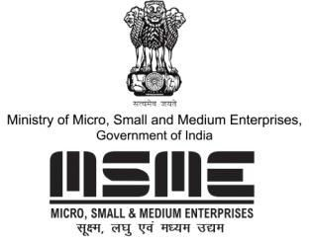

MSME TECHNOLOGY DEVELOPMENT CENTRE (CDGI)

MINISTRY OF MICRO, SMALL & MEDIUM ENTERPRISES, GOVT. OF INDIA

A1/1, Industrial Area, Jalesar Road, Firozabad 283203, Uttar Pradesh
•www.cdgiindia.net | Email: msme.cdgi@gmail.com
BUSINESS OPPORTUNITIES & ENTERPRENEURSHIP ON
SOLAR ENERGY
15th Feb, 2020
Fees: Rs. 3500+18%GST

VENUE
XON SOLUTIONS (TAI INFOTECH), BUILDING NO. 149, 4TH FLOOR, SECTOR 44, GURGAON, NEAR PUNJAB & SINDH BANK (1 KM FROM HUDA METRO STATION)
P

COURSE CURRICULUM FOR SOLAR ENERGY
Topics
- Brief about Solar Energy.
- Electric power scenario in India
- Reasons to invest in Solar in India
- Solar PV system
- Types of Solar PV systems
- What is solar panels
- Case study of solar PV System
- What is Solar OFF GRID system / ON Grid system
- Business Opportunities in Solar system in Indian market(Rural/Urban)
- Relationship development with dealers and suppliers
- Relationship development with customers
- Case study of Solar PV System
- How to setup a successful business in Solar Energy
- Various verticals in Solar Energy
- Efficient Revenue generation
- Government policies to help set up a solar business
- Resco Business
- How to become an EPC
- Maintenance of Solar System
- Open Discussion/Feedback session
- PRACTICAL SESSIONS & LIVE DEMOS INCLUDED

FOR MORE DETAILS PLEASE CONTACT:
Mobile: +91- 8800924880, 8168984069
E-mail: msme.cdgi@gmail.com
Website: www.cdgiindia.net, www.oorjatrainings.com

