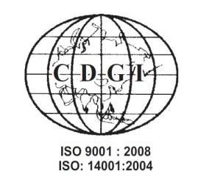
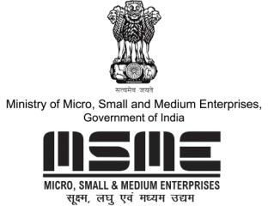

MSME TECHNOLOGY DEVELOPMENT CENTRE (CDGI)

MINISTRY OF MICRO, SMALL & MEDIUM ENTERPRISES, GOVT. OF INDIA

A1/1 , Industrial Area , Jalesar Road, Firozabad 283203, Uttar Pradesh
•www.cdgiindia.net | Email: msme.cdgi@gmail.com
HOW TO SUCCESSFULLY VENTURE INTO WORLD WIDE BUSINESS OF
EXPORT-IMPORT
19th & 20th Oct, 2019
Fees: Rs. 6,000/- + 18% GST

VENUE
HOTEL PEARL, 25/2 INDUSTRIAL AND BUSINESS PARK PHASE-2, CHANDIGARH

TOPICS
DAY -1 DAY-2
• International Standards on Packaging & Labelling
• WTO and Impact of Regional Groups on Business
• How to match the Foreign Trade POLICY for your business
• Latest Amendments in FTP 2015-20
• India’s Comparative Advantages for Business
• List of Export -Import items in India
• International Channels of Distribution and How to use them
• Indian Government Grants & Financing Schemes – How to claim incentives & Rebates
• Credit Risk Management
• How to save yourself from International Fraud?
• How to use e-commerce in export business marketing?
• Role of Trade Agreements- FTA
• Anti- Dumping Duties and Laws
• Government subsidies and financing schemes.
• Latest GST implications for Export- Import trade in India.
• Filling of papers for EBRC
• What is Export?
• How to setup your own export company (EXIM)
• What is Harmonize Code System (HS Code) for export Company?
• How to grab opportunities in EXIM business in India
• How to get root map and handholding support
• Product Clustering and segmentation in International market.
• Trading Principles
• How to search for Buyers / Suppliers and product for business in International Market
• How to communicate with overseas Buyers?
• Sending Free Samples.
• Negotiations in International Market
• How to Prepare Business/ sales contract?
• How to price your products for Exports
• How to process Export Order?
• Documentation used in India for export/ import?
• Stages of Preparing Documents
• Methods of payments (exercise for L/C)

FOR MORE DETAILS PLEASE CONTACT:
Mobile: +91- 8800924880, 8168984069
E-mail: msme.cdgi@gmail.com
Website: www.cdgiindia.net, www.oorjatrainings.com

