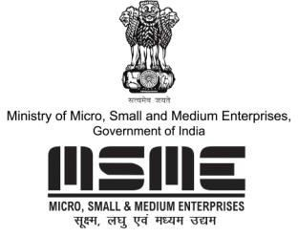
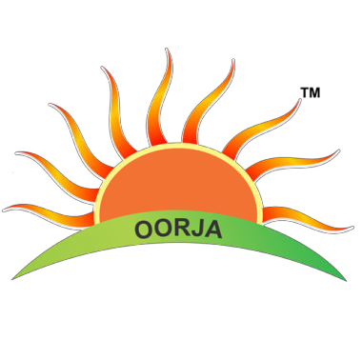

MSME TECHNOLOGY DEVELOPMENT CENTRE (CDGI)

MINISTRY OF MICRO, SMALL & MEDIUM ENTERPRISES, GOVT. OF INDIA

A1/1, Industrial Area, Jalesar Road, Firozabad 283203, Uttar Pradesh
•www.cdgiindia.net | Email: msme.cdgi@gmail.com
BUSINESS OPPORTUNITY ON PROTECTIVE CULTIVATION IN
ORGANIC & HYDROPONICS FARMING
01st March, 2020
Fees: Rs. 3,500/ + GST-

VENUE
YWCA DELHI, 1 ASHOKA ROAD, GATE NO. 1, NEAR BANGLA SAHIB GURUDWARA

COURSE CURRICULUM FOR ORGANIC & HYDROPONICS FARMING
Topics
- Business Scope in Organic & Hydroponics Farming
- Introduction to the world of Aquaponics Farming
- Seeding production with soil less media
- Rooftop Cultivation
- Soil Management
- Soil Manure & Nutrients
- Waste decomposition
- Multilevel Cultivation
- Hydroponics Cultivation
- Types of Hydroponics Systems
- Hydroponics Nutrients Management
- Mushroom cultivation
- All about Poly House, Net House & Tunnel House
- Policies & Schemes
- PGS Registration
- Open discussions / feedback session
- PRACTICAL SESSIONS AND LIVE DEMO INCLUDED

FOR MORE DETAILS PLEASE CONTACT:
Mobile: +91- 8800924880, 8168984069
E-mail: msme.cdgi@gmail.com
Website: www.cdgiindia.net, www.oorjatrainings.com

